CAHPR Small grants
2016 North East of England award scheme

Council for Allied Health Professions Research

CAHPR Small Grants

Introduction
The CAHPR mission is to develop AHP research at all levels, strengthen evidence of the professions’ value and impact for enhancing service user and community care, and enable the professions to speak with one voice on research issues, thereby raising their profile and increasing their influence
CAHPR has developed 23 research hubs across the UK with over 150 hub leaders and research facilitators who all operate on a voluntary basis. Each CAHPR hub plans activities to meet local needs to increase research capacity and capability. CAHPR Hubs main goals are to:
- Build AHP research capacity and capability
- Support the generation, dissemination and implementation of the evidence base within practice
- Develop AHPs’ scientific knowledge base by nurturing uni- and interdisciplinary research activity
- Increase AHP engagement with clinical academic career programmes
- Strengthen the AHPs’ research profile

Introduction
The CAHPR North East England hub ran a small grant scheme for the second year in 2016. Two grants of up to £1,000 were provided to support novice researchers. The scheme aimed to encourage two novice researchers to embark on a clinical research career pathway, increasing critical mass of clinical AHP researchers in the North East of England.
Funded projects were expected to result in small peer reviewed publications. Each grant holder presented at a hub meetings along with a key note speaker. This provided the opportunity for the two grant holders to disseminate their work and inspire other AHPs to get involved in research.

Feedback from 2016 winners

Caroline Fernandes-James, physiotherapist
Psychological Flexibility in Pulmonary Rehabilitation engagement
“The CAHPR award supported me to research a complex topic of COPD hospital admissions from conception to completion with collaboration from an excellent academic team at Teesside University.

The findings from the project will be translated to improve patient care in the North Tees and Hartlepool NHS FT and hopefully improve patient care. ”
Caroline Fernandes-James

Above: Caroline Fernandes-James

Here Caroline explains her role at North Tees and Hartlepool NHS as well as describing her research.
Tell us about your current role.
I am a Clinical Specialist Respiratory Physiotherapist and Joint Clinical Lead in pulmonary rehabilitation.
My role involves respiratory clinical expertise to COPD patients admitted to hospital, pulmonary rehabilitation and multi-disciplinary respiratory outpatient clinics at Lung Health Department North Tees Hospital.
I am joint clinical lead for pulmonary rehabilitation audit at NTHFT and service improvements. My role involves collaboration with commissioners and senior stakeholders regarding pulmonary rehabilitation service developments.
I am involved in training of practice nurses, allied health professionals and doctors in pulmonary rehabilitation. I am a clinical educator for pre-and post-registration students in physiotherapy, nursing and medicine.
Please explain your current research.
Pulmonary rehabilitation an exercise and education programme reduces breathlessness, chest flare-ups, hospital admissions and mortality in Chronic Obstructive Pulmonary Disease (COPD).
Rehabilitation within 4-8 weeks of a COPD hospital admission is offered to all patients on admission as part of the COPD Care bundle pathway however engagement is poor. Previous research indicates smoking, depression, disease severity, transport and lack of perceived benefit as reasons of non-attendance.
The psychological flexibility behavioural model involves acceptance, present moment attention, values identification and committed action. This model predicted flu vaccine uptake in COPD. The patients who took the vaccine were accepting of discomfort associated with the vaccine alongside its benefits.
Using the psychological flexibility behavioural model we explored if rehabilitation non-attendance results from avoidance of discomfort associated with exercising alongside difficulty linking rehabilitation to personal values.
43 patients with COPD hospital admissions completed 3 questionnaires within 4 days of a hospital admission .The Acceptance and Action Questionnaire and Engaged Living Scale (measures psychological flexibility). The Work and Social adjustment scale (measures functional impairment).
The questionnaire scores were compared with rehabilitation attendance, quality of life, breathlessness, number of flare ups and disease severity.
Audio-recordings were conducted with 20 patients to explore the cognitive processes behind a decision to accept or decline a rehabilitation referral.
Early analysis of the research data indicates a frail COPD hospital population with multi-morbidities and housebound. In the sample of 43 recruited patients, only 4 completed 12 sessions of rehabilitation and 3 patients have passed away within a 6 month period.
The qualitative feedback on barriers to attendance indicates motivation to attend rehabilitation but an awareness of severely impaired physical function, agoraphobia, awareness of dying, not wishing to worsen cardiac or musculoskeletal co-morbidities, feeling belittled, transport and finance issues and repeated flare ups of the condition.
Will this project influence your future research?
This project is providing insight into local Teesside COPD patient barriers to up taking pulmonary rehabilitation. Early insights indicate a frail ill population with complex multi-morbidities.

Fiona Bowe, physiotherapist
High intensity inspiratory muscle training (HI-IMT) in individuals referred for lung resection surgery
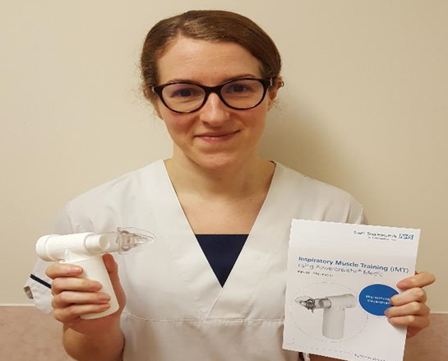
“Simplicity is key. The research process can seem overwhelming, having good support links and access to others with research experience is a great help. The award scheme has given me the boost to get involved and dip my toes into the research pool to enhance my practice.”
Fiona Bowe

A
Above: Fiona Rowe

Here Fiona explains her role at South Tees Foundation Trust James cook University Hospital and describes her current research.
Tell us about your current role.
I work as a Specialist Thoracic Physiotherapist within the wider Cardiothoracic Physiotherapy team supporting patients both of a cardiac and thoracic nature throughout their surgical journey.
Please explain your current research.
Surgical lung resection (removal of all or part of the lung) is the most effective treatment for curing localized lung cancer. Surgery affects the function of the respiratory muscles limiting deep breathing and effective coughing to clear mucus. This can increase the risk of infection and hinder lung expansion. Inspiratory muscle training (IMT) involves breathing in against a resistance to strengthen the respiratory muscles, perhaps reducing the likelihood of developing postoperative complications. The effectiveness of IMT in surgical populations is unclear, but to date mostly endurance-based training protocols have been applied (low resistance, long duration). To best improve strength, training ought to be performed at high resistance loads for short durations and therefore high intensity IMT (HI-IMT) may be a more appropriate training strategy.
Participants will be issued an inspiratory muscle training device (Powerbreathe Medic) at their pre-operative clinic. Once shown use of the Powerbreathe medic device Patients will be asked to complete 36 breaths (6 sets of 6 breaths) twice daily with rest intervals becoming progressively shorter between each set until returning for their operation. Post-operatively the use of the Powerbreathe medic will be recommenced after they have completed their inpatient Physiotherapy discharge goals until they return to their post-operative clinic review (4-6 weeks post-operatively).
Therefore, the purpose of this study is to explore if HI-IMT is feasible to deliver to individuals referred for a lung resection, if it is effective at improving: inspiratory muscle strength, infection rates, length of hospital stay, health-related quality of life, walking speed and if it is acceptable to patients. We hope that the information collected during this study will help to inform and improve our service enhancing patients’ surgical recovery and experience
Will this project influence your future research?
If HI-IMT delivered pre and postoperatively to individuals referred for a lung resection shows promising comparatives of variability of change in outcomes, and if patients likewise find the use of HI-IMT to be worthwhile this will be implemented as part of the new enhanced recovery after surgery within the thoracic surgical division at JCUH.

http://cahpr.csp.org.uk/

