CAHPR Small grants
2017 North East of England and Yorkshire joint award scheme

Council for Allied Health Professions Research

CAHPR Small Grants

Introduction
The CAHPR mission is to develop AHP research at all levels, strengthen evidence of the professions’ value and impact for enhancing service user and community care, and enable the professions to speak with one voice on research issues, thereby raising their profile and increasing their influence
CAHPR has developed 23 research hubs across the UK with over 150 hub leaders and research facilitators who all operate on a voluntary basis. Each CAHPR hub plans activities to meet local needs to increase research capacity and capability. CAHPR Hubs main goals are to:
- Build AHP research capacity and capability
- Support the generation, dissemination and implementation of the evidence base within practice
- Develop AHPs’ scientific knowledge base by nurturing uni- and interdisciplinary research activity
- Increase AHP engagement with clinical academic career programmes
- Strengthen the AHPs’ research profile

Introduction
The CAHPR North East England hub ran a small grant scheme for the third year in 2017. Three grants of up to £1000 were provided to support novice researchers with the aim of building research capacity by increasing the number of AHP active researchers.
For the first time the small grant scheme was delivered in partnership with the Yorkshire and South Yorkshire hubs. The aim of expanding the small grant scheme to two other regions was to provide the opportunity for AHPs from a wider geographical area to apply for funds and to provide the opportunity to disseminate research to a wider audience.

In addition NIHR Devices for Dignity contributed £500 to the awards and therefore priority was be given to funding one research project with a focus on patients with long-term conditions.

Primary or secondary research studies were accepted, but projects were required to have a multidisciplinary element with two or more different AHP disciplines represented on the project team.

The grant could be used to support any aspect of the study including but not limited to: salary costs, equipment, patient public involvement, and transcription costs.

The funded projects are expected to deliver findings within one year. At the end of the project the successful applicants will be asked to present their work at their local CAHPR hub and to write a short paper on their work.
Feedback from 2017 winners
Anna Anderson, physiotherapist
Does rehabilitation care before and after orthopaedic ankle surgery meet patients’ needs?
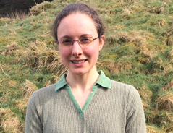
“This award provides an invaluable opportunity to undertake clinical research, with the ultimate aim of improving patient outcomes. Undertaking this research will provide me with new skills, experiences and networking opportunities that I hope to use as a platform for pursuing a career in musculoskeletal applied health research”
Anna Anderson

Above: Anna Anderson

Here Anna explains her role at the University of Leeds and describes her research.
Tell us about your current role.
I currently work as a musculoskeletal physiotherapist and treat people with a diverse range of conditions such as osteoarthritis, low back pain and tendinopathies. I am particularly interested in lower limb conditions and promoting health behaviour change. I believe that education and exercise play a vital role in helping people prepare for surgery, recovery from surgery/injury and manage long-term conditions.
Please explain your current research.
Approximately 3000 people with end-stage ankle arthritis undergo total ankle replacement or ankle arthrodesis each year in the UK, yet outcomes vary and failure/revision rates are higher than for hip and knee replacements. A recent audit in Leeds suggested patients undergoing total ankle replacement or ankle arthrodesis receive limited rehabilitation care. Extensive evidence supports the role of rehabilitation in improving patients’ post-surgical outcomes and overall experiences of hip and knee replacement surgery. The limited rehabilitation care provided to patients undergoing total ankle replacement or ankle arthrodesis is therefore a major concern.
This study will investigate this issue through exploring patients’ experiences of rehabilitation care before and after total ankle replacement and ankle arthrodesis surgery. This will include establishing whether current rehabilitation care meets patients’ needs and how this influences patients’ post-surgical outcomes.
Semi-structured interviews will be conducted with eight participants who have undergone total ankle replacement or ankle arthrodesis. Participants will be purposefully selected based on their surgical outcome and gender. The interviews will explore participants’ clinical characteristics, the rehabilitation care they received pre- and post-surgery, participants’ perceptions of their rehabilitation care and their overall experiences of surgery. Data will be analysed using thematic analysis. The research will be disseminated through submission to professional journals/conferences, provision of plain English summaries to all participants and presentation of the findings to the Leeds Biomedical Research Centre Patient and Public Involvement group.
The findings of this research will provide an in-depth insight into current orthopaedic ankle surgery rehabilitation care and identify whether this care meets patients’ needs. This will provide vital information for guiding future care provision and highlight priorities for future research.
Will this project influence your future research?
Yes, definitely. I am hoping to use the new skills and experience I will gain through this research as a platform for pursuing a career in musculoskeletal applied health research. My short-term goal is to undertake a PhD focused on improving pre-operative orthopaedic care. This research is highly relevant to my proposed PhD project and will provide me with an opportunity to work with experts in musculoskeletal applied health research.

Jennifer-Jane Turner, physiotherapist
Leg strengthening device. Discussion groups involving clinicians and patients to assess the clinical need and optimal design
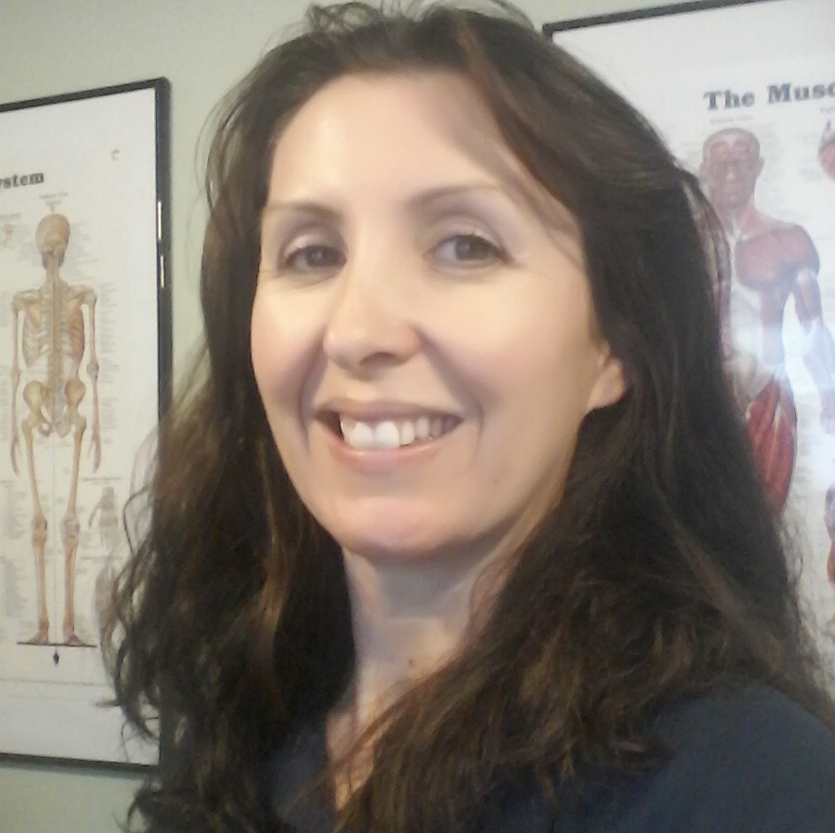
“The small research award has enabled me to perform and manage crucial discussion groups to make sure that I have all the best information to move my project forward successfully. I would encourage any AHP with an idea for improving patient outcomes to apply for this competition and make it happen.”
Jennifer- Jane Turner

Above: Jennifer-Jane Turner

Here Jennifer-Jane explains her role at Best You Can Be Physiotherapy and her research.
Tell us about your current role.
I am a physiotherapist working in private practice. Also, I own a new med tech company that is working to develop innovative rehabilitation devices
Please explain your current research.
The aim of the research / discussions was to question the group participants on their views and opinions of the new leg strengthening device and concept designs being shown and what they thought could be improved in its design and function before final development and manufacture. This was to make sure that there was a need for the device and that its design was optimal for use by therapists and to enable the best physical outcome for their patients.
I organised and managed three discussion groups. Two involved clinicians from various backgrounds and a third group involved the Sheffield PPI group. I had support from the Therapy Lead at Sheffield Teaching Hospitals to set up the groups and advice on catering and how to best manage the groups. In total, there have been approximately 30 people involved in the participating in the group discussions. I used a Dictaphone to record the groups and have had these transcribed. The information received was very positive and is now being used to determine the final concept designs for manufacture.
Will this project influence your future research?
Yes, the discussion groups have been very successful, and they have enabled me to alter the design of the leg strengthening device to better suit the needs of clinicians and patients that will use it.

Joseph Bradley, occupational therapist

Sensory processing patterns in Chronic Fatigue Syndrome / Myalgic Encephalomyelitis (CFS/ME)
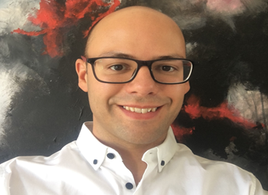
“Being awarded the grant and having the feedback from the panel increased my confidence in taking forward research activities, and I hope the experience and outcomes will support future research. The award has been used to buy the necessary resources and allowed me to devote some time to taking the project forward.
I would encourage other AHPs who are interested in research to start small and make links with universities so you have their support and expertise as you are learning.”
Joseph Bradley

Above: Joseph Bradley

Here Joseph describes his current role at Yorkshire Fatigue Clinic and explains his research.
Tell us about your current role.
I work as an occupational therapist at the Yorkshire Fatigue Clinic, a service specialising in assessment and rehabilitation for people with persistent fatigue, in particular Chronic Fatigue Syndrome/Myalgic Encephalomyelitis. We work collaboratively with people with CFS/ME at all severities, from being able to work or study, or bed-bound.
As a clinical area where understanding of the condition and effective treatment is still lacking, we are always interested in new research about the condition and its management and have been involved in recruiting and data collecting for national research studies.

Please explain your current research.
This study aims to:
- Pilot a research methodology to identify sensory processing patterns and styles in response to everyday sensory stimuli in adults with CFS/ME

- Evaluate feasibility and design of the study for application in a full-scale research project - ascertaining resources and capacity required, potential problems in implementing the method at a larger scale, and determining an appropriate sample size for statistical power
A convenience sample of 25 adult volunteers with self-reported CFS/ME will be recruited through local support groups for CFS/ME. Data will be collected from participants via an online or paper questionnaire, and include completion of the Adolescent/Adult Sensory Profile (AASP) - a 60 item self-report questionnaire that evaluates behavioural responses to everyday sensory experiences, self-assessed level of severity of illness using the ME Association disability rating scale (0-100%), gender, age, and comorbidities.
Statistical analysis will be used to identify differences in processing styles between collected data and normative values of the AASP, and to examine whether certain variables affect processing profile.
Evaluation of the pilot will be conducted by the research team to identify feasibility and modifications to the method for translation into a larger scale statistically powered study, considering: recruitment, eligibility criteria, population representation, consent rates, completion rates, feedback from participants and investigators, resources, and adverse events.
Will this project influence your future research?
The research project is designed as a pilot project to evaluate the method of research, and inform progression to a larger extensive study, which may be as part of doctorate studies. Additionally, the process of design and implementing the study has increased my network with other researchers and therefore I hope that future collaboration with them may be possible

http://cahpr.csp.org.uk/

