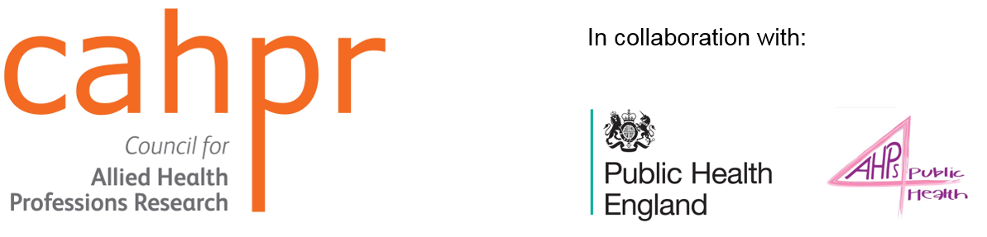
CAHPR Public Health Research and Evaluation Awards 2020
Abstract submission form

Details of submitting author
Full name:
Organisation/institution:
City
Country
E-mail
Work telephone
Mailing address
Profession
Professional body registered* with and number:  *Applicants must be HCPC/GOSC registered AHPs | Please note membership numbers will be checked with the professional organisation that you are registered with
Details for co-author 1(if applicable)
Full name:
Organisation/institution
City
Country
Details for co-author 2 (if applicable)
Full name:
Organisation/institution
City
Country
Details for co-author 3 (if applicable)
Full name:
Organisation/institution
City
Country
If you have additional authors, please add extra lines to the table.

Abstract details
Title of abstract | (maximum 20 words)
Relevance to Public Health Priorities  (please state which Public Health England priority you feel your research/service evaluation relates to using the list provided by deleting those it does not apply to ) | - Tackling obesity, particularly among children  - Reducing smoking and stopping children starting  - Reducing harmful drinking and alcohol related admissions  - Ensuring every child has the best start in life  - Tackling the growth in antimicrobial resistance  - Promoting workplace wellbeing  - Promoting mental wellbeing  - Increasing physical activity  - AHP interventions showing an impact on population health outcomes and/or wider determinants of health
Methodology  Please state your chosen methodology by deleting from the list) | Qualitative  Quantitative  Mixed methods  Systematic review  Service Evaluation  Clinical audit  Quality review
Ethics Approval
Please name the ethics committee that approved your work and provide the reference number where appropriate.
If ethics approval was not required, please state this & provide a clear rationale for this decision and explain how this decision was reached.
(maximum 50 words)
If you win the award you will need to be available to attend the Public Health England Conference in September 2020 to display your poster.

Abstract (Guide: Total 500-600 words)
Relevance
How does the project relate to the PHE Priorities?

Purpose
Research and systematic reviews: What was the major reason for doing the study? State the aims and objectives and any secondary objective

Service evaluation: what is the main reason for your study? What is the purpose of sharing this activity?

Methods
What principles/methods/methodological approach were used?

For research reports describe selection criteria and sample size

Results
What were your main findings from your analysis?
Conclusions
What can be concluded from the analysis of your data? What are the suggestions for future work?

Service evaluations: what future research do you plan to develop?

Impact and Implications
What are the implications of the project?
How will the results be translated into AHP practice / management / education / policy?

Funding Acknowledgement
Please acknowledge all funding sources that supported your work. If the work was unfunded please state this.

References (up to 5, please use Vancouver referencing system)
(not included in word count)
Published or Presented  Has this work been previously published or due to be published elsewhere? | - Yes  - No
Did you contact a CAHPR Hub for advice? | - Yes  - No

I confirm that the abstract submitted is my own work

Name

Signature

Date

I am happy to contacted by Public Health England, CAHPR or AHPs4PH for further information about the abstract I have submitted
Yes
No

I am happy for CAHPR, Public Health England and AHPs4PH to use my name and the information provided in my abstract to showcase research undertaken by AHPs
Yes
No

Please send completed abstracts to
CAHPR@csp.org.uk
to arrive no later than 9.00 a.m on 30 April 2020

Please mark the email subject with your name.

By completing and submitting this form, you are agreeing to your data being processed by the Chartered Society of Physiotherapy on behalf of the Council of Allied Health Professions Research (CAHPR) for the purposes of managing your application.
You can withdraw your permission for us to use your data in this way however by doing so it may mean we cannot provide you with a place at this workshop.
The CSP’s privacy statement can be viewed at this link: https://www.csp.org.uk/privacy

