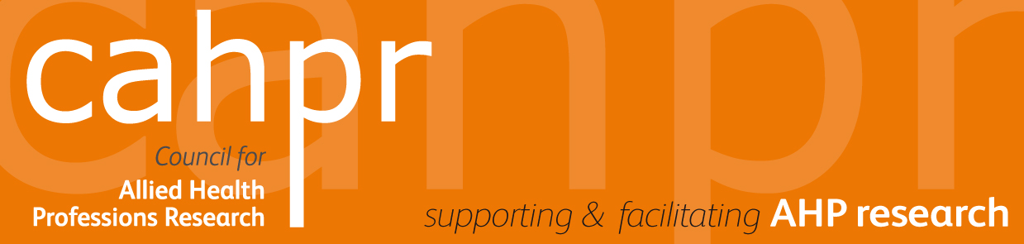
SMALL RESEARCH AWARDS COMPETITION
Closing Date: 1st September 2020
CAHPR North East of England hub is running a competition to support AHP research and innovation in the region.
The aim is to support up to six AHPs, who are novice researchers, to carry out a small piece of research/innovation, with a view to facilitating these six candidates to develop a research active career in the future.
Given the current circumstances with COVID-19 this year the applications must be limited to systematic reviews, secondary analysis of secondary data sets or, if ethics boards allow, studies that do not involve any direct contact, for example emailed surveys or telephone interviews. Up to six studies will be funded to a maximum of £1,000 each. The money can be used to support any aspect of the study including but not limited too; salary costs, access cost or licences and transcription costs.
NHS Durham Dales, Easington and Sedgefield CCG and NHS North of England commissioning support unit are contributing £4000 to the awards and therefore 4 studies funded must be focused on primary care or community work involving primary care networks.
Applications are invited from qualified AHPs who are interested in enhancing their research capability. The application should be made as a group (with two or more people in the group). The lead applicant must be a qualified AHP; the co-researchers do not have to be so. The lead applicant must be a novice researcher (i.e. they must not have or be registered for a PhD). Within the team there should be an individual who has experience of supervising research students who will act as the applicant’s supervisor. If you are a novice researcher who would like to apply but you are not part of a group and do not know anyone who would be willing to act as a supervisor, please contact us and we will attempt to put you in touch with a suitable supervisor.
The research must have a multidisciplinary element. Ideally two or more different AHP disciplines will be represented on the project team, however projects involving other disciplines i.e. nurse, physician, physiologist etc., will also be considered. Studies with a strong multidisciplinary element will be looked upon favourably.
The proposed project should be able to deliver findings within one year. At the end of the project the successful applicants will be asked to present their work at their local CAHPR hub and to write a short paper on their work.
If you have any questions or would like more information please contact:
Cormac Ryan (North East England hub) at c.ryan@tees.ac.uk
(Please see following page for form and address to send your application to)
CAHPR North East of England hub: Small Research Awards Scheme
Application Form

This application form should be accompanied by a 1 page CV of both the lead applicant and their supervisor.
Please email your application to: c.ryan@tees.ac.uk by 1st September 2020.

Applicant details:
Profession & Professional registration number:
Title:
Name:
Current post:
Organisation:
Address:

Email address:
Co-researchers including Supervisor Details (add more rows as required)
Name & profession | Institution | Email

Project Details:
Project title (25 words max):
Project Duration (in months):
TOTAL FUNDING REQUESTED £
Background (150 words max):
Aims & objectives (100 words max):
Plan of Investigation (300 words max):
To include: study design, population, methods and analysis
Briefly describe the multidisciplinary nature of the study (100 words max):
Potential impact of study (150 words max)
To include plans for dissemination as well as impact in terms of improving clinical service, wellbeing of patients, public health services etc.
Your future career plans (100 words max)
References:
1)
2)
3)
4)

